NST21022 - Practical for Network Switching and Routing
Department of Information and Communication Technology
Faculty of Technology
Lab sheet :04
Reg. Number: SEU/IS/20/ICT/084
Academic Year :2020/2021
Practical No :04

Title: Network devices configuration practice
Aim:
• Get practice with basic configuration in Router and Switch
Task:
• Follow the lab sheet and configure network device accordingly

Design a network as follows
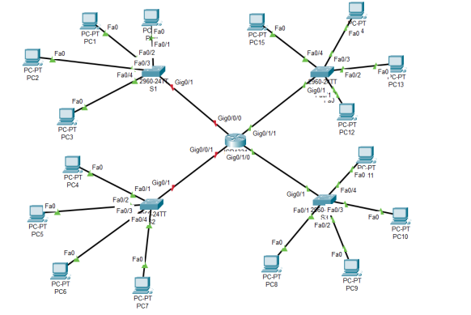
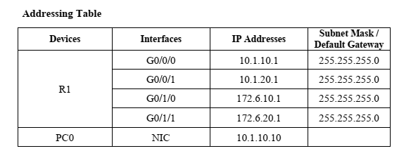
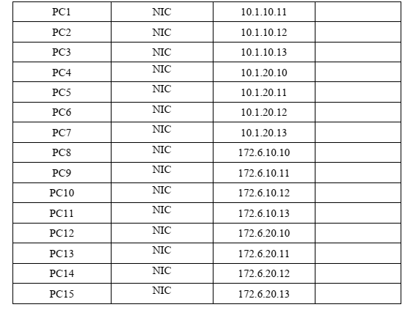
Activities
Exercise 01:
- Create a topology as mentioned above.
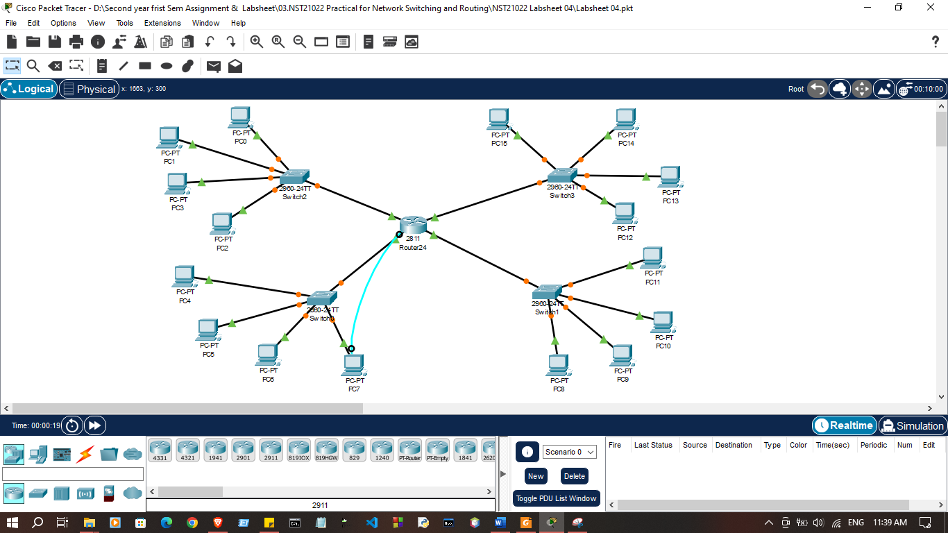

- Configure basic configuration on router and switches through console cable from any PC.

- Configure hostname according to display name
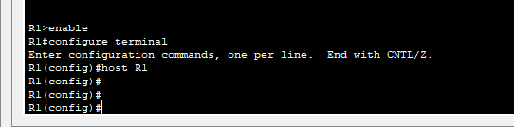
- Prevent unwanted DNS lookup
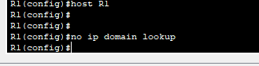

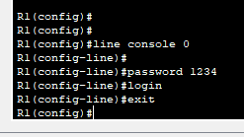
- Configure password protection to console line

- Configure VTY line password.

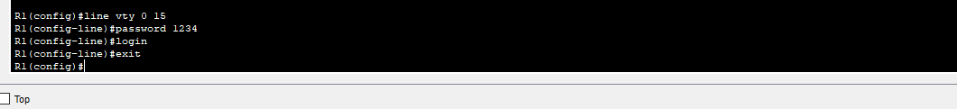

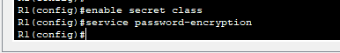
- Configure password protection to privileged EXEC mode

- Encrypt all password

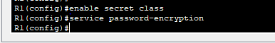

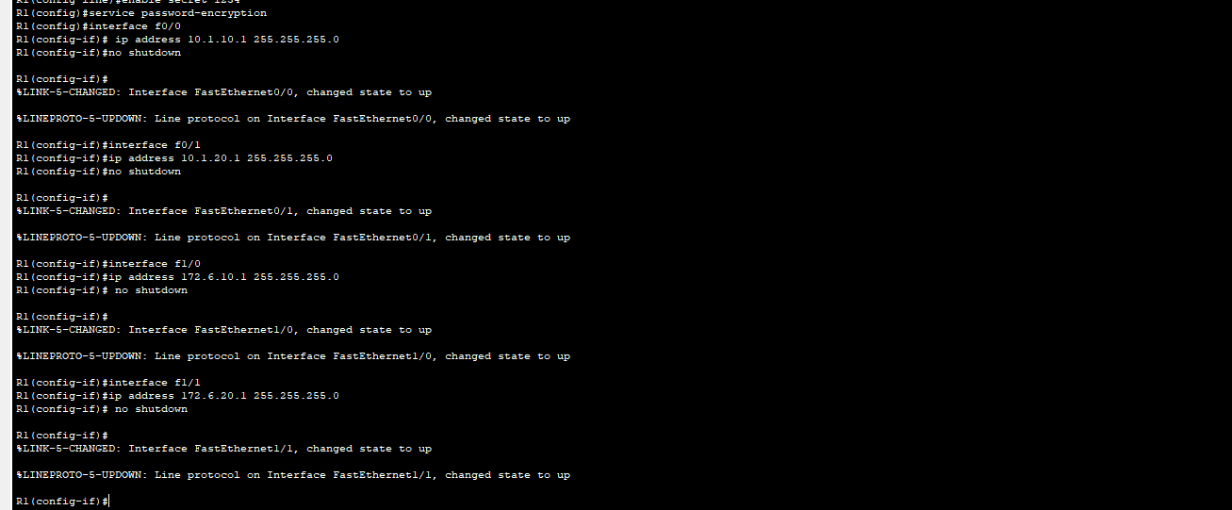
- Assign IP addresses to the interfaces according to the addressing table

- Configure proper banner message

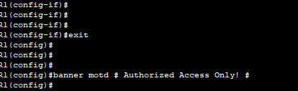

- Save configurations
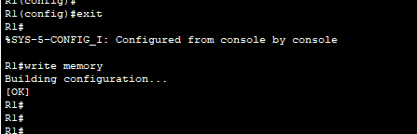

- Verify running configurations on router
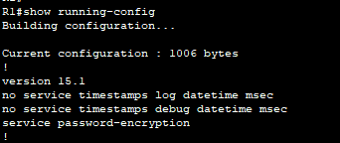

- Try to ping between PCs If pinging not success discuss and find a solution
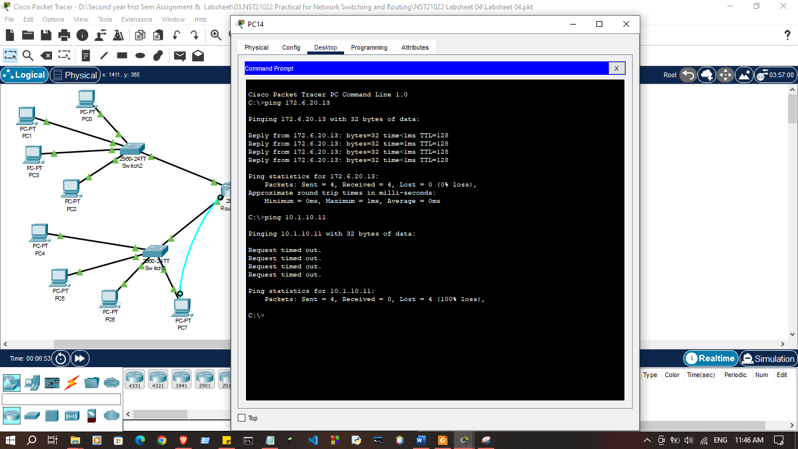

Discussion:

- In this lab session, we focused on practicing basic configurations for routers and switches. Following the lab sheet instructions, we configured network devices step-by-step to set up a functional network. This included tasks such as assigning IP addresses to router interfaces, configuring switch ports, enabling basic routing protocols, and securing access to the devices through passwords. These configurations helped us understand the fundamental setup required for network communication and reinforced our skills in managing and operating network devices like routers and switches.

